A TECHNICAL REPORT ON
STUDENT INDUSTRIAL WORK EXPERIENCE SCHEME (SIWES)

CARRIED OUT AT
USAKO BREAD INDUSTRY,
HONG, ADAMAWA STATE

FROM: AUGUST, 2025
TO: DECEMBER, 2025

TITLE PAGE

BY

CHINAPI SUNDAY
(SAS/FST/ND/24/002)

A SIWES REPORT SUBMITTED TO THE DEPARTMENT OF FOOD SCIENCE TECHNOLOGY, SCHOOL OF APPLIED SCIENCE, FEDERAL POLYTECHNIC, MUBI, ADAMAWA STATE, NIGERIA

IN PARTIAL FUFILMENT OF THE REQUIREMENTS FOR THE AWARD OF NATIONAL DIPLOMA (ND) IN FOOD SCIENCE TECHNOLOGY,

FEBRUARY, 2026

APPROVAL PAGE
This is to certify that Chinapi Sunday with a registration number SAS/FST/ND/24/002 has undergone his student industrial training at Usako Bread Industry, Hong, Adamawa State. In partial fulfilment for the award of national diploma (ND) in Food Science Technology Federal Polytechnic Mubi as certified by the undersign officer.

………………………………….. ……………………………
MR. USMAN U. WAFARI Date
DEPERTMENTAL SIWES COORDINATOR

DEDICATOIN
This report is dedicated to God almighty for this wisdom and strength and my lovely parents for their love and care throughout the period of my siwes training.

ACKNOWLEDGEMENT
I thank God Almighty for making me to undergo students industrial work experience scheme (SIWES) successfully.
My gratitude goes to my lovely parents for their prayers, financial and moral support during my attachment.
I also appreciate the kind gesture of my brothers and sisters and those who supports me in prayers and contribution during my industrial attachment.
I whole heartedly thank my Head of Department, SIWES coordinator and all lecturers of Food Science Technology Department for their effort to ensure my success as their students.
I am greatly indebted to my co-SIWES students to mention, may God strengthen our relationship together and grant us academic excellence.
I sincerely thank you all for your contribution and support.

TABLE OF CONTENTS

TITLE PAGE i
APPROVAL PAGE ii
DEDICATOIN iii
ACKNOWLEDGEMENT iv
TABLE OF CONTENTS v
CHAPTER ONE 1
1.0 INTRODUCTION 1
1.1 Background of SIWES 1
1.2 Brief History of SIWES 1
1.3 Objectives of SIWES 2
2.1 Brief History of Usako Bread Industry Gombi 3
2.2 Organizational Chart 3
CHAPTER THREE 4
EXPERIENCED GAINED DURING THE INDUSTRIAL TRAINING 4
3.2 PROCESSING OF BAKERY PRODUCTS 6
3.2.1 Processing of Bread 6
3.2.2 Processing of Buns 7
CHAPTER FOUR 8
SUMMARY, CONCLUSION AND RECOMMENDATIONS 8
4.1 Summary 8
4.2 Conclusion 8
4.3 Recommendations 9
REFERENCE 10

CHAPTER ONE

1.0 INTRODUCTION
The concept behind industrial training schemes is to acquire practical, knowledge in addition to what has been learn institution. The four months mandatory supervised industrial attachment is program instituted by the federal government to help student for their different field of studies.

1.1 Background of SIWES
It aims at exposing student to the practical and the actualization of work situation which they may meet after graduation and the learning is meanly expected to produce graduate qualification to meet man power of employments of (ITF), there was growing concern amount the industrialist that graduate of higher learning do not passes adequate background student for the opinion that theoretical education going higher institution was responsive enough to meet the need of employers of the labour as a requirement of national board for technical education (NBTE) polytechnic training before obtaining the National Diploma (ND). Experience scheme (SIWES), is a National programme introduced by Government in 1974 for student in tertiary institution.

1.2 Brief History of SIWES
SIWES was established by ITF in 1973 to solve the problem of lack of adequate practical skills preparatory for employment in industries by Nigerian graduates of tertiary institutions.
The program “Student industrial work experience scheme” is a pure skill-acquisition program structured for the tertiary institutions as a complementary and enhancement program to the theoretical education, laboratory and workshop practices engaged in by student in different higher institutions. The SIWES was initiated to improve the student’s technical abilities (performance/knowledge) and expose them to industrial culture thereby preparing them to be acquainted with the roles to play towards the technological advancement of the nation.
It is there for a practical aspect of the academic works, which the students may not be opportune to carry out throughout their stay in the higher institutions. Based on this fact, the Federal Government decided to establish a body (regulatory) which engages in the training of the technical manpower. The body is named industrial Training Fund (ITF). The government also undertook to make up for the deficiencies by structuring and established Students Industrial Training (SIT) as it was then called but in 1973 the SIWES was formed which is the subsidiary.

1.3 Objectives of SIWES
- One of the objectives of SIWES is to create an avenue for students to acquire industrial skills to complement their theoretical knowledge and improve their experiences in their course of study.
- The program prepares the students for industrial working conditions prior to their graduation.
- To enable the students to learn personal relationship with employers and co-employees on graduation.
- It exposes the student to working methods and techniques in handling equipment and machinery.
- It develops the student in make critical and realistic approaches to solving problem.
- It serves as a way of improving the abilities of the students and to contribute to the growth of the nation.
- It gives the students the opportunity to practice what they have been taught in various disciplines.
- The SIWES program strengthens the employer’s involvement in preparing the students for employment.

CHAPTER TWO

2.1 Brief History of Usako Bread Industry, Gombi
Usako Bread Industry was established in 2015 by Dauda Elijah. It started with a few people of five (5) with production of buns. By that time there was no engine, all mixing was done by hand and production was in low quantity. With the grace of God, today the company has grown and expanded and is now using machines such as mixing machine, meter scale, slider and oven.
As the population of Hong and surrounding communities like Gombi and Pella grew, Usako Bread Industry scaled its operations. The industry transitioned from traditional wood-fired ovens to more modern, industrial-grade baking equipment to ensure consistency and hygiene.

2.2 Organizational Chart
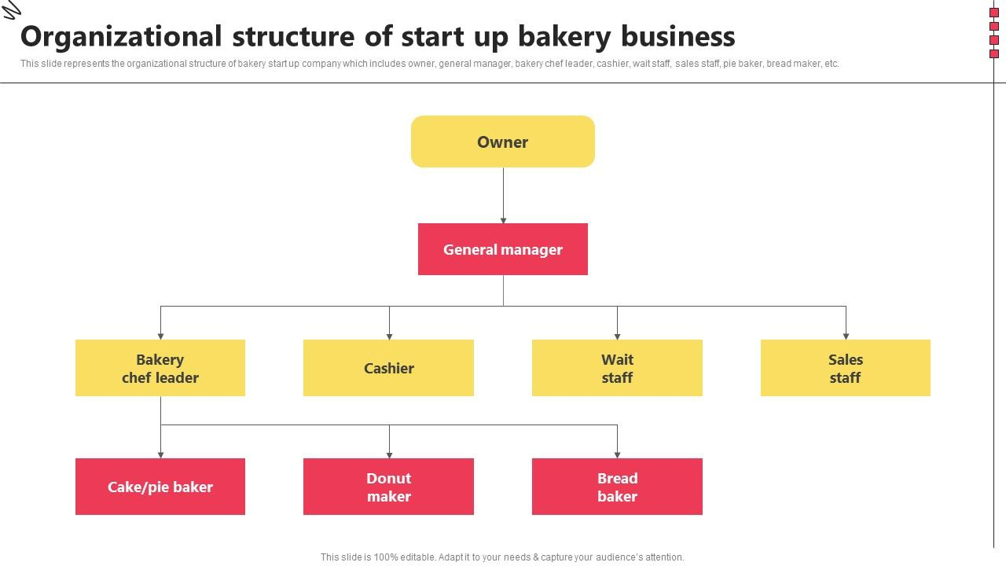
Figure 2.1: Organizational chart

CHAPTER THREE

EXPERIENCED GAINED DURING THE INDUSTRIAL TRAINING
3.1 Mixing of Flour
Mixing is a fundamental operation in bakery production that involves the thorough blending of flour with other ingredients such as water, yeast, sugar, fat, salt, and eggs to form a uniform dough. The main objectives of mixing are to evenly distribute ingredients, hydrate flour particles, develop gluten structure, and incorporate air, which contributes to dough elasticity, strength, and final product quality. Mixing can be carried out either manually (hand mixing) or mechanically (machine mixing).
3.1.1 Mixing of Flour Using a Machine
Machine mixing is commonly used in commercial and industrial bakeries due to its efficiency, speed, and consistency. Dough mixers such as spiral mixers, planetary mixers, or horizontal mixers are designed to handle different dough types and batch sizes.
Process of Machine Mixing
First, all ingredients are accurately weighed to ensure consistency and quality control. Dry ingredients such as flour, sugar, and salt are usually added into the mixing bowl first. Yeast may be mixed with water or added directly depending on the formulation. Liquid ingredients, including water, milk, eggs, and melted fat, are then added gradually.
The mixer is started at a low speed to combine the ingredients and prevent flour dusting. At this stage, the ingredients are blended until a shaggy or rough dough is formed. The mixing speed is then increased to promote proper hydration of the flour and development of the gluten network. As mixing continues, the dough becomes smooth, elastic, and cohesive.
Throughout the process, temperature control is important to prevent overheating, which can damage gluten structure and reduce yeast activity. Once the dough reaches optimum development characterized by smoothness, elasticity, and extensibility—the mixer is stopped, and the dough is removed for fermentation or further processing.
Advantages of Machine Mixing
- Ensures uniform mixing and consistent dough quality
- Saves time and labor
- Suitable for large-scale production
- Provides better control over dough development
Disadvantages of Machine Mixing
- High initial cost of equipment
- Requires electricity and technical maintenance
- Risk of over-mixing if not properly monitored
3.1.2 Mixing of Flour by Hand
Hand mixing is commonly practiced in small-scale bakeries, home baking, and training environments. It involves manual blending of ingredients using hands or simple tools such as wooden spoons or spatulas.
Process of Hand Mixing
In hand mixing, flour is placed in a clean mixing bowl or flat surface. Dry ingredients such as sugar, salt, and yeast are first mixed evenly with the flour. A well is then created at the center of the flour, into which liquid ingredients like water, milk, or eggs are gradually added.
Using the fingers or a spoon, the ingredients are gently mixed, gradually incorporating the flour into the liquid. Once the mixture begins to form a dough, the baker uses hands to knead the dough by pressing, folding, and stretching it repeatedly. This action hydrates the flour and develops gluten structure through physical manipulation.
Hand mixing continues until the dough becomes smooth, elastic, and non-sticky. The dough is then shaped into a ball and allowed to rest or ferment as required.

Advantages of Hand Mixing
- Does not require electricity or expensive equipment
- Allows better tactile control and assessment of dough consistency
- Suitable for small-scale production and training
- Low operational cost
Disadvantages of Hand Mixing
- Time-consuming and physically demanding
- Inconsistent results if technique varies
- Not suitable for large-scale production
- Higher risk of contamination if hygiene is poor
Machine mixing offers speed, efficiency, and uniformity, making it ideal for commercial bakery operations. In contrast, hand mixing provides greater control and flexibility for small batches but is labor-intensive and less consistent. The choice of mixing method depends on production scale, available resources, and desired product quality.

3.2 PROCESSING OF BAKERY PRODUCTS
Food processing involves the transformation of raw materials into edible and acceptable food products through various physical, chemical, and biological methods. In food science, bakery processing is an important area that involves the use of flour and other ingredients to produce products such as biscuits, cookies, and bread. During the SIWES programme, practical exposure was gained in the processing of these bakery products, with emphasis on ingredient formulation, mixing, baking, and quality evaluation.

3.2.1 Processing of Bread
Bread processing involves fermentation and baking to produce a soft, porous food product. The main ingredients include wheat flour, yeast, water, sugar, salt, and fat.
Steps in Bread Processing
- Ingredients such as flour, yeast, sugar, salt, fat, and water were accurately weighed.
- All ingredients were mixed to form dough.
- The dough was kneaded to develop gluten structure.
- The dough was allowed to ferment for a specified time.
- The fermented dough was punched down to remove excess gas.
- The dough was molded and shaped into loaves.
- The shaped dough was proofed until it increased in size.
- The proofed dough was baked in an oven at the required temperature.
- The baked bread was cooled, sliced, and packaged.

3.2.2 Processing of Buns
Buns are small, sweetened baked products made from enriched wheat flour dough. The processing of buns involves mixing, kneading, fermentation, shaping, and baking to produce a soft, slightly dense, and flavorful product. The major ingredients used in buns production include wheat flour, yeast, water or milk, sugar, salt, fat (butter or margarine), and eggs, which contribute to the taste, texture, and nutritional quality of the buns.
Steps in Buns Processing
- Ingredients such as flour, yeast, sugar, salt, fat, eggs, and water or milk were accurately weighed.
- All the ingredients were mixed thoroughly to form a smooth dough.
- The dough was kneaded properly to develop the gluten structure and ensure uniform texture.
- The dough was allowed to ferment for a specified period to improve flavor and softness.
- The fermented dough was punched down to release trapped gases.
- The dough was divided, molded, and shaped into small bun portions.
- The shaped dough was proofed until it increased in size.
- The proofed buns were baked in an oven at the appropriate temperature until golden brown.
- The baked buns were removed from the oven, cooled, and packaged for storage and distribution.

CHAPTER FOUR

SUMMARY, CONCLUSION AND RECOMMENDATIONS

4.1 Summary
The relevance of the SIWES program cannot be over emphasized considering the fact that it has significantly reduced the gap between my theoretical and practical knowledge about computer hardware and software, installations, maintenance and networking. The processes of communication which include data and telecommunication the use of switch in the networking and what networking is all about.
The program is indeed a commendable one in that it affords students ample opportunities of being exposed to good working relationship with colleagues and the field experience with customers. This little exposure has widened my knowledge about my course of study, not only that it has automatically changed my views about lift in general. The firm at large has taught me how to be independent of my own how to be conscious of my health and safety at its peak relating to the environment where I carried out my SIWES program. It was indeed a highly rewarding experience to be with Modibbo Adama University, Yola, Adamawa State.

4.2 Conclusion
In conclusion, I thank ITF in general for their effort towards the Student Industrial Training Scheme. The contribution that the industrial training offered to student will not be over emphasized. It has exposed me seriously to a certain depth and length of practical capability on Computer Knowledge and practical Know how.
It has also acquainted me with the working condition, which I am expected to encounter in the near future. I will say that SIWES has a greater advantage on me, it has greatly exposed me to the practical application of all that I have been through in the school, SIWES is an experience that all student must pass through this is because it gives a full practical knowledge of what has been through in classroom.
Finally, I have a strong believe that this comprehensive based on the experience, I acquired during the industrial training scheme will convince every user training is not difficult.

4.3 Recommendations
Having gone through this training my recommendation are:
- The students should be well supervised, both from the ITF and institution
- The institution supervisor should be from the students department so as to be able to dictate any fault.
- The organization should make provision for some amount to stimulate the students monthly.
- The students that are ready to learn should be well enlightened from the organization.

REFERENCES
Adegboye, R. O. (2012). Challenges of industrial training in Nigeria. Lagos: Yaba College Press.
Akinyemi, S. (2011). Bridging the skills gap in Nigerian higher institutions: The SIWES approach. Nigerian Journal of Educational Research, 14(3), 22–29.
Industrial Training Fund (ITF). (2010). SIWES Policy Document. Jos: ITF Publications.
Oladele, J. O., & Akintayo, M. O. (2013). Effectiveness of the Students’ Industrial Work Experience Scheme (SIWES) in Nigerian tertiary institutions. Journal of Technical Education and Training, 5(1), 35–42.

